Lab 4.2 Cucumber Installation

This section will guide you to:

* Install cucumber, and run with JavaScript
* Use visual studio code (the popular text editor for web-based projects)
* Confirm the cucumber installation via npm

**Step 4.2.1:** Install Node.js and npm from the official site

Go to [www.nodejs.org/en/](http://www.nodejs.org/en/) and download the LTS version for smooth and efficient workflow.

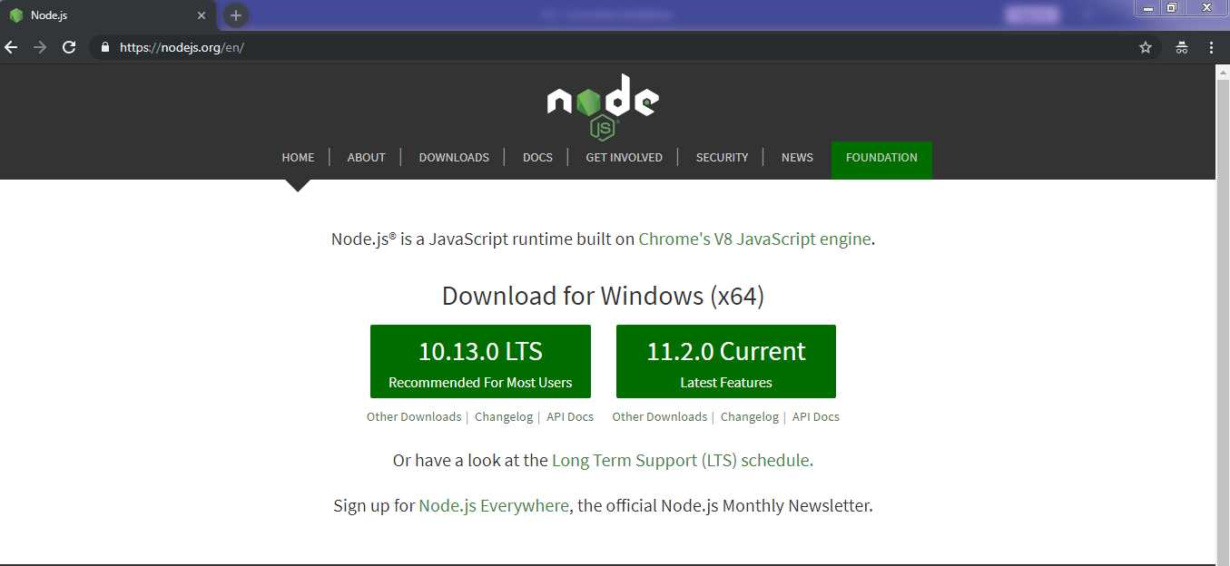

Install the node.js in your system by running the command below in the terminal.

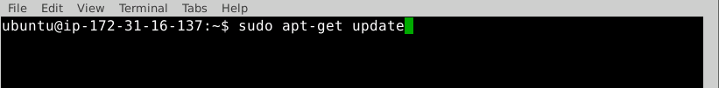



Once the installation is complete, open your command prompt and type the command mentioned below to check the versions of node and npm.

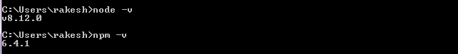

If you’re unable to find the latest version in the Ubuntu labs, then continue with the instructions given below; otherwise, skip this step and continue with step 2.

**Alternate 1:**

If you find the oldest version of the node, then execute the commands below in the terminal.

sudo npm cache clean -f

sudo npm install -g n

sudo n stable

To upgrade to the latest version, run the command below.

sudo n latest

**Alternate 2:**

Run the command given below to install the Node.js v10.x version.

curl -sL https://deb.nodesource.com/setup_10.x | sudo -E bash -

sudo apt-get install -y nodejs

**Step 4.2.2:** Download visual studio code from the official site <https://code.visualstudio.com/download> and click on **.deb** button to download the software.

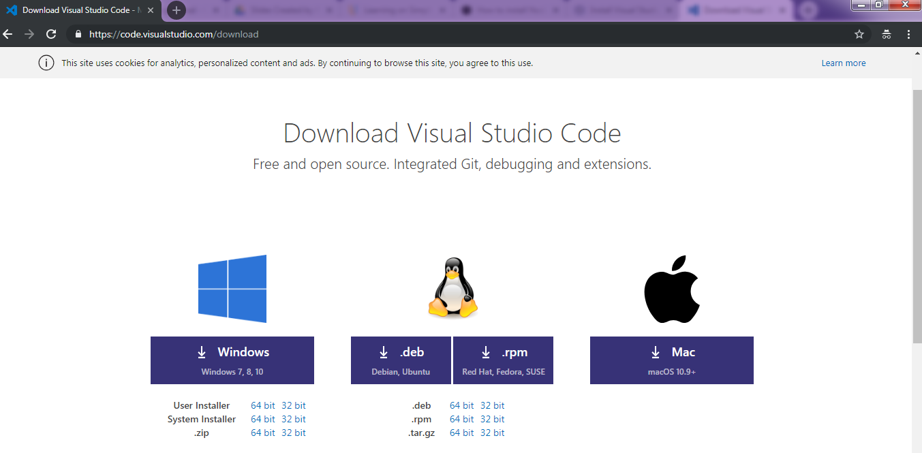

Open the terminal, and run the command given below to install the visual studio code.



To open the visual studio code editor, click on the  button available on the top-left side in the lab and select **Development** and click on **Visual Studio Code**.

**Step 4.2.3:** Create a separate folder via terminal and navigate inside the folder. An example folder name with commands are mentioned below:



Go to the visual studio code editor, and open the newly created folder performing the following steps in the editor.

**File** → **Open Folder…[Ctrl+K+Ctrl+O]** and navigate to the newly created folder.

Type **Ctrl+`** or navigate to **View → Terminal.**

Type the following commands (without ‘#’) in the visual studio code’s terminal to install cucumber.



Create a folder and a subfolder with the names, features, and steps as shown below:

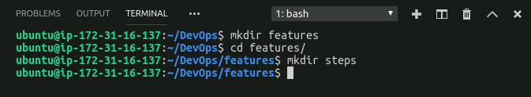

Create a file named “**cucumber.js**” inside the project folder with the following code.

module.exports = {

default: `--format-options '{"snippetInterface": "synchronous"}'`

}

The project directory should be:

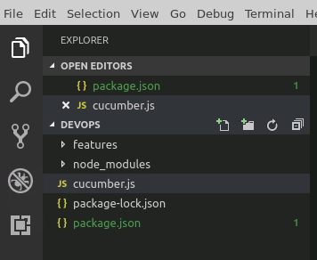

Create a file as “**stepdef.js**” inside the **features/steps/** directory and add the following code.

const assert = require('assert');

const { Given, When, Then } = require('cucumber');

The project directory should be:

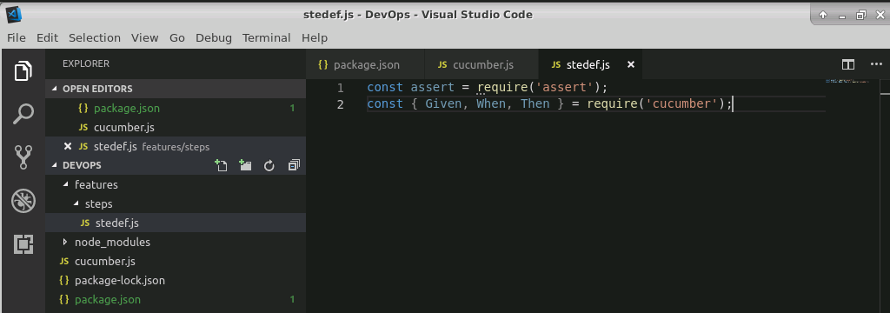

Click on “**package.json**” file, and edit the code of test:

From: “test”: “echo \”Error: no test specified\ “”

To: “test” : “cucumber-js” and save the file.

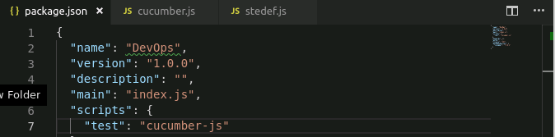

Run “**npm test**” in the terminal of visual studio code to confirm that cucumber is installed. The following output confirms that cucumber is installed properly.

